Cancer treatment, yes or no?
- Introduction:
Cancer is a major global public health challenge; in developed countries, it is the second cause of death after heart disease (1). Metastasis plays a unique role in the spread of cancers that lead to death. They migrate through blood vessels and enter other tissues and eventually cause the involvement of healthy body tissues (2). The term angiogenesis means the formation of new capillaries from existing vessels, first used in 1935 by a researcher named Hertig (3, 4). Angiogenesis is required for many pathological processes, including invasive tumor growth and physiological organ/tissue maintenance. (5) Angiogenesis is a critical step in tumor metastasis. It has been proven that tumors need nutrients and oxygen for tumor growth and metastasis. The initiation of tumor angiogenesis involves several molecules, such as the release of pro-angiogenic factors such as vascular endothelial growth factor (VEGF), which activate several signaling pathways that lead to the formation of new vessels (6, 7). In the following, we will examine angiogenesis’s stimulating and inhibiting factors. So far, many endogenous factors that inhibit angiogenesis have been identified, many of which are naturally derived from the extracellular matrix, and some are basement membrane proteins. In general, angiogenesis inhibitors are divided into two main classes, which include matrix-derived inhibitors and non-matrix-derived inhibitors (5).
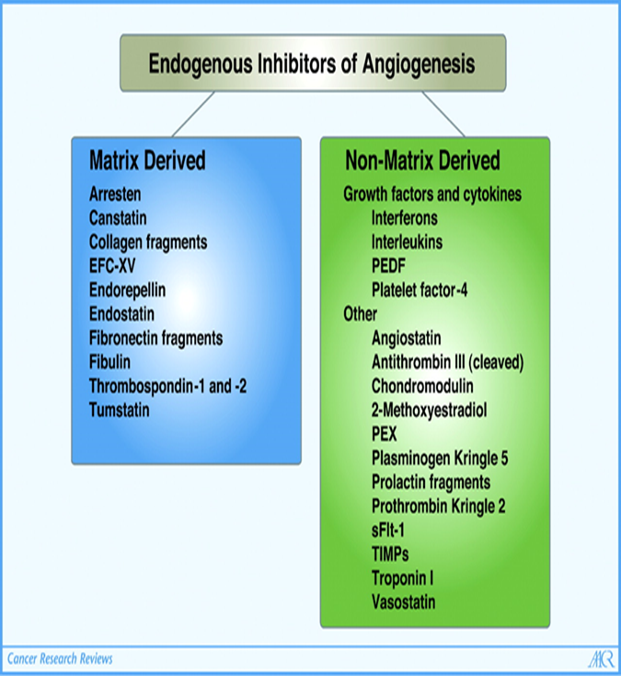

- Angiogenesis inhibitors derived from matrix sources

  - Canstatin
Canstatin consists of 24 kilodalton fragments of type IV collagen α2 chain. Studies conducted with recombinant canstatin have shown that this molecule effectively inhibits endothelial cell migration and tube formation in a dose-dependent manner. Canstatin also prevents the proliferation of human endothelial cells stimulated by serum and activates apoptosis without inhibiting the increase or apoptosis of non-endothelial cells. (8)
  - Endorepellin
Perlecan is a heparan sulfate proteoglycan of the basement membrane that plays a crucial role in vascular growth. The carboxyl end of perlecan, called endorphin or the 5-domain of perlecan, effectively inhibits angiogenesis through various mechanisms. Among these mechanisms are the prevention of endothelial cell migration and the formation of tubular structures stimulated by collagen, the inhibition of blood vessel growth in chorioallantoic membrane tests, and the prevention of endothelial cell attachment to fibronectin and type 1 collagen without direct extension to the matrix above proteins. In addition, endorphin binds to endostatin, another matrix-derived angiogenesis inhibitor that counteracts its anti-angiogenic effects. (9, 10)
  - Endostatin
Endostatin is an endogenous inhibitor of angiogenesis derived from collagen type 18, which was first purified from the murine hemangioendothelioma cell line and later identified and characterized in mice. A recombinant form of endostatin, a 20 kDa fragment derived from the NC1 carboxyl domain of collagen type 18, inhibits angiogenesis and suppresses primary tumor growth and metastasis in laboratory animal models without significant side effects, toxicity, or drug resistance. New studies have also shown that endostatin has various other actions such as interfering with the signaling induced by 2-FGF, inhibiting endothelial cell motility, stimulating apoptosis, arresting the G1 phase in endothelial cells by inhibiting cyclin D1, inhibiting signaling through VEGF by Direct interaction with tyrosine kinase receptor of vein endothelial cells in Flk-1/KDR/VEGF-R2 of the umbilical cord and suppresses necrosis factor stimulation. It seems that this molecule binds to αβ integrin and inhibits the migration of endothelial cells by blocking Ras and Raf-dependent signaling pathways (11, 12).

- Angiogenesis inhibitors derived from non-matrix sources:

  - Angiostatin
Plasminogen contains five kringles. The cleavage of this enzyme by proteases leads to the formation of 38-45 kilodaltons anti-angiogenic peptides, which contain Kringle domains with triple sulfide bridges, such as Kringle 1 to 4 or Kringle 1 to 3, and are collectively called angiostatin. Some studies have shown that Kringle 5 has antiangiogenic activity on its own. Angiostatin inhibits endothelial cell proliferation and migration. One of the goals of angiostatin action is direct binding to the ATP synthetase enzyme on the surface of endothelial cells. This action may lead to the decrease and fall of intracellular pH and therefore cause apoptotic events in endothelial cells. In addition, both angiostatin and plasmin have been shown to bind to αvβ3 integrin. Angiostatin specifically inhibits cell migration induced by plasmin. This approach suggests that plasmin binding to integrin αvβ3 is necessary for its activity, and angiostatin may interfere with such activity (13).
  - Cleaved antithrombin III and prothrombin kringle-2
The coagulation factors circulating in the blood play an essential role in angiogenesis. Various research has shown that in addition to angiostatin, thrombospondins, platelet factor 4, antithrombin 2, and prothrombin Kringle 2, which have antiangiogenic properties, are present in the blood. Cleaving the carboxyl end ring of antithrombin gives it antiangiogenic solid and antitumor properties by causing a conformational change in the molecule. Studies have also shown that Kringle's prothrombin domain two inhibits endothelial cell proliferation (14).
  - Interferons
They are cytokines with multiple or pleiotropic effects and are among the first known endogenous regulatory factors with antiangiogenic properties that also regulate antiviral, antitumor, apoptotic, and cellular immune responses. The study of the effect of cytokines on angiogenesis induced by mouse tumor cells proves their inhibitory action. Studies have also shown that α-IFN or β-IFN has biological activity against squamous cell carcinomas and prevents angiogenesis in tumor-bearing nude mice. In addition, researchers have shown that factors derived from cartilage also inhibit the proliferation and migration of endothelial cells by inhibiting the activity of collagenase because the breakdown and dissolution of collagen is the essential step in angiogenesis.
Although individual parts of hyaluronic acid have angiogenic effects, this acid with high molecular weight prevents angiogenesis in bud limb embryo chick model. It causes the differentiation and growth of vessels, mainly through increasing tissue hyaluronidase activity. Also, hyaluronic acid can increase the growth rate of newly formed capillaries around the places under the skin (15).

- Interfering with endothelial cell growth:
One of the most successful strategies to inhibit angiogenesis is using agents that specifically inhibit the growth of endothelial cells. One of the first compounds to show inhibitory effects on cell growth, especially endothelial cells, was the compound O-chloroacetylcarbamoyl fumagillol. This compound is an antibiotic analog derived from the fungus fumagillin. During the following years, several Endogenous molecules with angiogenesis inhibition activity were identified. Among these molecules, we can choose from Thrombospondin-1, platelet factor-4, and interferon-induced protein-10. Two other members of this class that is produced endogenously are the antiangiogenic proteins Angiostatin and Endostatin. Another independent strategy to intervene in angiogenesis is to deal with angiogenic factors such as VEGF or FGF and their receptors (16, 17)
In this context, the researchers of our country, like other researchers around the world, using angiogenesis models, succeeded in studying, identifying, and studying a variety of angiogenesis-inhibiting compounds, such as the identification of anti-angiogenesis peptides from shark cartilage, anti-plasminogen monoclonal antibody, Kunitz trypsin inhibitor from seeds. Soybean, the study of the antiangiogenic properties and mechanisms of the shallot plant and the sage plant, (as well as the study of the antiangiogenic effect of green tea and beeswax extract.

- Conclusion and discussion
Because the increasing resistance of cancers to common treatments has become a troublesome problem, efforts are being made to discover and identify new anti-cancer agents that increase the sensitivity of cancer cells. The resistance of cancer cells to chemical drugs leads to a decrease in the response level of these cells to the drug and, as a result, the failure of treatment measures. Therefore, the research and development of more effective medicines with fewer side effects are increasingly important (50). Folkman was one of the first researchers who proposed the use of inhibiting the formation of tumor vessels for cancer treatment. His suggestion and other research have led to the development of research and clinical investigation of more than 20 different drugs that inhibit various stages of angiogenesis. Among the potential advantages of this type of treatment that can be mentioned include easy access to intravascular targets, the absence of the problem of tumor cell resistance compared to conventional chemotherapy against cancer, and the broad application of this type of strategy to treat many kinds of angiogenesis-related diseases.
Therefore, inhibiting angiogenesis is important because cancer cells may show less resistance to treatment with this method. After all, this issue is directly and more related to the stroma and not to the genetically unstable tumor cells. The design of this idea is based on the fact that the processes used by endothelial cells in angiogenesis are not the result of genetic changes in the activity of the oncogene suppressor gene of endothelial cells. In other words, the absence of drug resistance to angiogenesis inhibitors in the process of antiangiogenesis therapy is most likely because endothelial cells are genetically active and do not mutate into drug-resistant forms. Although this type of treatment is up-and-coming, the lack of resistance strongly depends on the type of angiostatic treatment used (18).
Considering what was mentioned and the importance of angiogenesis in research related to the discovery and identification of angiogenic factors and angiogenesis inhibitory factors for the treatment of various diseases, including types of tumors that are closely related to angiogenesis and are dependent on it, methods of inhibiting angiogenesis that aim Interfering with this critical process is a promising path for the treatment of angiogenesis-related diseases. Based on this, the development and use of different angiogenesis models for this purpose become more and more critical to the extent that many researchers worldwide benefit from other angiogenesis models to study this important phenomenon and its influencing factors.

References
1. Ferlay J, Soerjomataram I, Dikshit R, Eser S, Mathers C, Rebelo M, et al. Cancer incidence and mortality worldwide: sources, methods and major patterns in GLOBOCAN 2012. Int J Cancer. 2015;136(5):E359-86.
2. رمضانی ط, بهارآرا ج. مروری بر رگزایی (Angiogenesis) در تومور. 1393.
3. Ribatti D, Nico B, Crivellato E, Roccaro AM, Vacca A. The history of the angiogenic switch concept. Leukemia. 2007;21(1):44-52.
4. Egginton S. Invited review: activity-induced angiogenesis. Pflugers Arch. 2009;457(5):963-77.
5. Nyberg P, Xie L, Kalluri R. Endogenous inhibitors of angiogenesis. Cancer Res. 2005;65(10):3967-79.
6. Hayat M. Tumors of the Central Nervous System, Volume 1: Gliomas: Glioblastoma (Part 1): Springer Science & Business Media; 2011.
7. Tiwari M. Apoptosis, angiogenesis and cancer therapies. J Cancer Ther Res. 2012;1(1):3.
8. Bix G, Castello R, Burrows M, Zoeller JJ, Weech M, Iozzo RA, et al. Endorepellin in vivo: targeting the tumor vasculature and retarding cancer growth and metabolism. J Natl Cancer Inst. 2006;98(22):1634-46.
9. Zheng MJ. Endostatin derivative angiogenesis inhibitors. Chin Med J (Engl). 2009;122(16):1947-51.
10. Ribatti D. Endogenous inhibitors of angiogenesis: a historical review. Leuk Res. 2009;33(5):638-44.
11. Lee TY, Muschal S, Pravda EA, Folkman J, Abdollahi A, Javaherian K. Angiostatin regulates the expression of antiangiogenic and proapoptotic pathways via targeted inhibition of mitochondrial proteins. Blood. 2009;114(9):1987-98.
12. Larsson H, Akerud P, Nordling K, Raub-Segall E, Claesson-Welsh L, Björk I. A novel anti-angiogenic form of antithrombin with retained proteinase binding ability and heparin affinity. J Biol Chem. 2001;276(15):11996-2002.
13. Shukunami C, Hiraki Y. Role of cartilage-derived anti-angiogenic factor, chondromodulin-I, during endochondral bone formation. Osteoarthritis Cartilage. 2001;9 Suppl A:S91-101.
14. Otrock ZK, Makarem JA, Shamseddine AI. Vascular endothelial growth factor family of ligands and receptors: review. Blood Cells Mol Dis. 2007;38(3):258-68.
15. Madri JA, Williams SK. Capillary endothelial cell cultures: phenotypic modulation by matrix components. J Cell Biol. 1983;97(1):153-65.
16. DiPietro LA, Nebgen DR, Polverini PJ. Downregulation of endothelial cell thrombospondin 1 enhances in vitro angiogenesis. J Vasc Res. 1994;31(3):178-85.
17. Quesada AR, Muñoz-Chápuli R, Medina MA. Anti-angiogenic drugs: from bench to clinical trials. Med Res Rev. 2006;26(4):483-530.
18. Boehm T, Folkman J, Browder T, O'Reilly MS. Antiangiogenic therapy of experimental cancer does not induce acquired drug resistance. Nature. 1997;390(6658):404-7.

